Gary’s Posture App v1.2

# System Requirements

An Android Phone running Android 2.3.5 minimum fitted with an external SDCard or an emulated external SDCard if the phone does not have a slot for an SDCard.

# Features

* Alerts the user to incorrect posture due to leaning forward or back too far.
* Graph of latest session showing the users vertical position over time and when and how often thresholds were exceeded.
* All sessions data may be downloaded in csv format and analysed in a spreadsheet application.

# How it works

GarysPosture App uses the phones in-built accelerometer to detect if the phone is tilted at an angle greater than a user pre-set angle from a user calibrated vertical position.

The user is alerted to this tilt by the phones in-built vibrator.

The phone is carried in your shirt pocket so that it moves as you do. It is important that the phone fits snugly in the pocket so that the sensitivity to tilting can be maximised.

The accelerometer is sampled approximately every 500ms and then a moving average is applied to the raw value to smooth out short term deviations to reduce false alarms.

A user set update interval determines how frequently the user is alerted to bad posture.

# Limitations

These limitations exist for Version 1.0 of the App, future versions may remove some of these limitations:

1. This version only detects tilt forward or backward. Later versions may also detect left or right tilt.
2. Once started, the app must remain in the foreground, i.e. you cannot open another app whilst it is monitoring. A future version will remove this limitation.
3. You need to have an External SDCard or emulated External SDCard on the phone to allow you to install the app as it is not available on the Google Play store.
4. You need to have an External SDCard or emulated External SDCard on the phone to access the saved data files for analysis if you desire.
5. The Graph function only works on the monitoring session that has just been stopped.
6. The time on the Graph is not user friendly.
7. Some phones turn off the accelerometer when the screen blanks. This prevents the app from determining if you are leaning so it effectively stops monitoring. There is an option in the app to keep the screen on at its lowest illumination. This will impact battery life but testing so far has not indicated any issue over several hours of continuous use.

# Installation

As this app is not available on the Google Play store you will need to install this app on your phone using a method known as side loading. You will need to have an SDCard installed in your phone or the phone needs to emulate an external card if it does not have an SDCard slot.

Connect your phone to your computer via its USB cable and enable USB Storage mode to allow you to save the apk file to your phone.

Copy the apk file over to the phone, taking note of the directory you copy it to on the phone.

Disconnect the phone from the USB cable.

Open your phones file manage and navigate to the directory you copied the apk file to.

Tap the apk file and your phone should install the application. It will now show up in your apps and you can place it on one of your home screens.

# Initial Setup

The first time you use the app you will need to calibrate the vertical position. First of all practice putting the phone into your shirt pocket in the way that you intend to use it to monitor your posture. Pay attention to the orientation and which direction you have the screen facing.

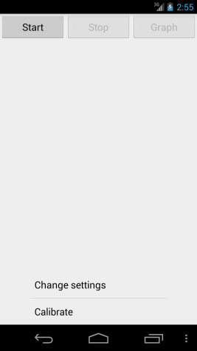

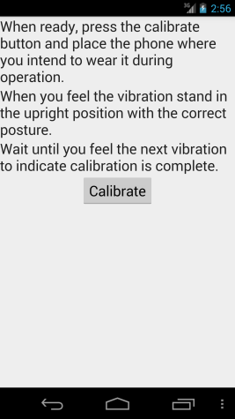Now open the app.

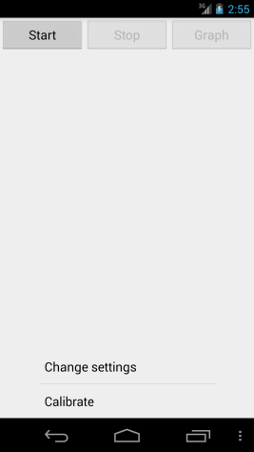

At the home screen open the Preferences/Setting Menu as you normally would and select “Calibrate”

There is a bit of a blurb about what to do, essentially you need to load the phone into your pocket exactly as you will when you are using the app to monitor your posture. Before you put it in your pocket you need to tap the Calibrate button. You have about 5 seconds to place it in your pocket. You will feel it vibrate, this means calibration has started. Stand in the desired upright position until you feel the phone vibrate again (about 5 seconds later).

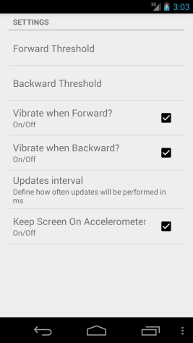You will be returned to the Home Screen. From there you can review the other settings and adjust as you like.

Once again, open the Preferences/Setting Menu and select “Change Settings”.

The Threshold values are dimensionless and represent how far you can lean before being alerted. A larger number is a larger lean.

The Updates Interval determines how often you are alerted that you are exceeding one of the thresholds. For example if Updates Interval is set to 2 Seconds and you are leaning forward too far for more than 2 seconds you will be alerted every 2 seconds until you correct your posture.

The final Check box is a workaround for certain mobile phones. These phones turn off the accelerometer whenever the screen blanks. When this box is checked, the phones screen will remain on at its lowest illumination level while ever the app is monitoring. A future version may include a test to determine the phone’s capabilities.

The easiest way to test if your phone does this is to un-check this box, set your update interval to 0.5 seconds, go back to the Home screen, press the start button and tilt your phone until it starts vibrating. Hold it in this position until your screen turns off. If the phone continues to vibrate then you can leave the box un-checked. Go back in and reset the update interval to at least 1 second or longer.

If it stops vibrating this means your accelerometer shut off when the screen blanked so you will need to check the box.

# Operation

Once you have run the calibration you are ready to go. Simply press the start button and place the phone in your pocket or wherever you are going to wear it (see Suggestions below).

If you lean too far forward you will be alerted by a dot-dot-dot vibration pattern.

If you lean too far back you will be alerted by a dash-dash vibration pattern.

The home screen displays the current filtered value, updated about every half second.

When you are ready to stop monitoring, take the phone out and press the Stop button. You can review your posture over the last session by tapping the Graph button. It will show you both the Raw data (in Cyan) and the Smoothed data (in Green). The upper and lower alert thresholds are shown as Red lines.

# Analyse saved data

Each session is saved to the phones SDCard as an Excel friendly csv formatted file. The timestamp on each data point is the phone clock time in hours:minutes:seconds.

You can download these files to your PC by connecting your phone via USB and navigating to the location indicated. Normally the files will be stored under the Downloads/Gary directory.

# Suggestions

During testing it has become apparent that ideally you should use a dedicated phone for this app. It can be an old phone you have laying around or you can purchase a cheap prepaid (sometimes they are at a deep discount because they are locked to a network with an expensive plan. In that case you never activate the plan so you get a cheap platform)

If you use a dedicated phone I recommend you turn on airplane mode to turn off wifi, Bluetooth and especially the cell radio. By doing this you save a lot more power than you lose with the screen on low.

Another recommendation would be to purchase a travel neck safety pouch, like you use for carrying cash and cards when travelling, for example something like <http://www.walmart.com/ip/Protege-Travel-Neck-Wallet/17472589> not sure of its exact size but it would need to hold your phone snugly. You could always modify it as necessary.

# Future Improvements

Some of the things I intend to do if this works out to be useful are:

* Automate the check for screen blanking and the accelerometer
* Change to a background service so that you can use the phone to do other things while monitoring and alerts run in the background.
* Add a monitoring schedule so you can set days and times to automatically turn on and off monitoring.
* Add the ability to select sessions to graph instead of just the last one.
* Add an email/dropbox/Google Drive option to export the data.
* Add another Axis so that side to side leaning can be monitored.
* Custom vibration selection so you can choose from a variety of patterns for each direction.
* Use a more modern style of Android interface. Currently pegged to Android 2.3 as that was my test phones version.
* Suggestions from you as you use it.

# Changelog

V1.2 – Timetamp on csv data is actual time

Data is saved to file during monitoring rather than at the end of a session

V1.1 – Initial Release